  - PRODUCT MANUAL

RV Gas Water Heater
  - Installation, Operation and Maintenance Instructions

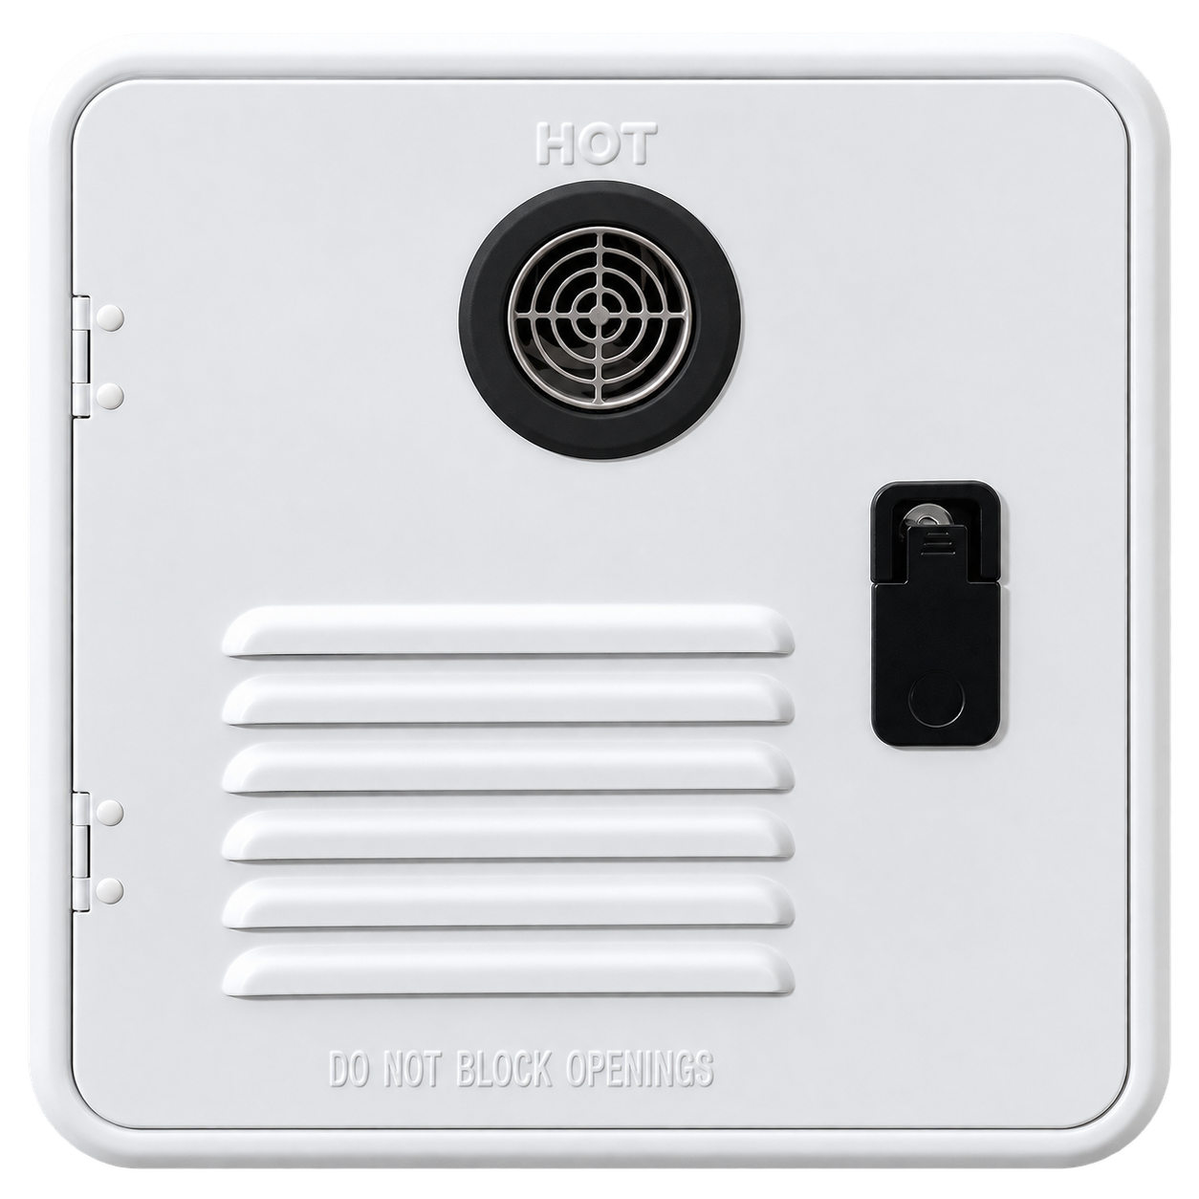
Vehicle-integrated exterior access module - product appearance may vary by configuration
Model | RVW-LP09-01
Brand | Joelwave
Document | English - Revision 1.0
IMPORTANT
Read this manual completely before installation or operation. Installation and service must be performed by a qualified RV gas-appliance technician in accordance with local codes and the final approved installation drawing.

1. Important Safety Information
DANGER - CARBON MONOXIDE
Combustion products contain carbon monoxide. Keep the air intake and exhaust outlet unobstructed. Never operate the appliance if the exhaust system is damaged, blocked, modified or discharging into an enclosed area.

WARNING - FIRE OR EXPLOSION
Failure to follow gas-safety instructions may cause fire, explosion, property damage, serious injury or death. Do not store or use gasoline, aerosols or other flammable vapors and liquids near the appliance.

If you smell gas
- Evacuate all persons from the recreational vehicle.
- Shut off the LPG supply at the cylinder or source.
- Do not operate electrical switches, phones, radios, engines or generators in or near the vehicle.
- From a safe location, contact the gas supplier, a qualified service technician or the fire department.
- Do not restore the gas supply until the leak has been located and repaired.

Intended use
This appliance is intended only for heating water in recreational vehicles used for travel, recreation or camping. It is not designed as a space heater, pool heater, marine heater, food-truck appliance or permanent residential water heater.

Owner responsibilities
- Maintain a working carbon monoxide detector and LPG detector in the RV.
- Keep the exterior door, air intake, exhaust outlet and drain openings clear.
- Turn off the appliance and LPG supply while refueling, in tunnels, on ferries, in garages or other enclosed spaces, and whenever required by the RV manufacturer.
- Do not modify safety devices, wiring, burner, gas valve, controller or exhaust components.
- Use the appliance only with potable water and within the specified operating conditions.

2. Product Overview
The RVW-LP09-01 is a forced-exhaust, constant-temperature LPG water heater designed for vehicle-side integration. A separate wired controller allows temperature setting and status monitoring from inside the RV.
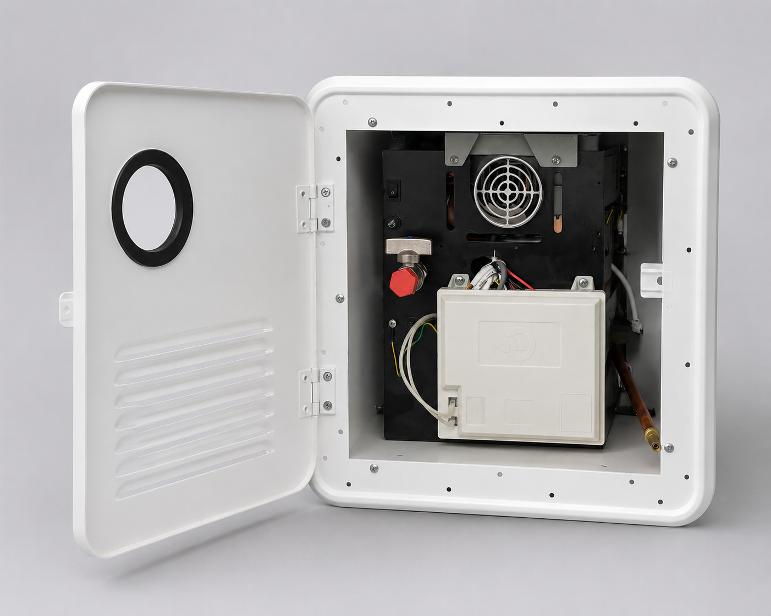
Open service compartment - component positions shown for identification only
Main Assemblies
Exterior module | Painted 1 mm steel access door with lock and two keys
Heat exchanger | Oxygen-free copper assembly, approximately 1.32 kg, 85 fins
Combustion system | Five-nozzle, segmented burner with forced exhaust
Remote controller | BW-TXK038 touch controller with 5 m, 5-pin cable
Main control | BW-HK201 electronic control system
Water path | Copper piping with rear inlet and selectable front/rear hot-water outlet

3. Technical Specifications
Rated Data
Model | RVW-LP09-01
Fuel | Liquefied petroleum gas (LPG)
Maximum heat output | 58,000 / 61,000 BTU/h, configuration-dependent
Maximum hot-water flow | 9 L/min (2.4 GPM)
Set-temperature range | 35-51 degrees C (95-124 degrees F)
Nominal gas supply pressure | 2.8 kPa
Operating water pressure | 0.1-0.4 MPa (14.5-58 psi)
Pressure-relief valve | 150 psi
Electrical input | 12 V DC, 5 A supply
Controller working range | 10-17 V DC; maximum controller output 53 W
Ignition | 8 +/- 1 seconds; maximum 2 ignition attempts
Burner noise | <=60 dB
Shutdown noise | <=80 dB
Timeout protection | 40 minutes; restart by stopping and restoring water flow
Net weight | 13.5 kg
Packed size | 45.5 x 42.5 x 45.5 cm
Packed weight | 14.5 kg

SPECIFICATION CONTROL
Product dimensions, wall cutout, fastener pattern and minimum clearances must be taken from the final approved production drawing and installation template. Do not cut the RV wall from a preliminary specification sheet.

Operating environment
Controller ambient temperature | -10 to 70 degrees C
Controller storage temperature | -20 to 80 degrees C
Relative humidity | Below 95%, non-condensing
Water-flow sensor range | 1-20 L/min
Minimum start flow | >=2.5 L/min
Shutdown flow | <=2.0 L/min

4. Supplied Components
Item | Quantity | Notes
RV gas water heater | 1 | Vehicle-integrated exterior module
Remote controller and cable | 1 | 5 m cable, 5-pin aviation connector
Power cable | 1 | 2 m, 2-pin appliance connector to bare leads
Door keys | 2 | For exterior access-door lock
Shower set | 1 | Chrome-plated ABS hand shower, 10-position flow adjustment
Shower hose | 1 | 1.5 m, 304 stainless-steel outer body with silicone hose
Sealing washers | 2 | Fit inside shower-hose connectors

Before installation
- Inspect the appliance and accessories for shipping damage.
- Verify the model, gas type, electrical rating and connector standard on the rating label.
- Confirm that the final installation drawing, wall cutout template and fastener specification match the delivered unit.
- Do not install or operate an appliance that is damaged, incomplete or configured for the wrong fuel.

5. Installation Requirements
QUALIFIED INSTALLATION REQUIRED
Gas, electrical, water, exhaust and structural work must be completed and leak-tested by qualified personnel. The installer is responsible for compliance with applicable RV, LPG, electrical, plumbing and ventilation codes.

Location and clearances
- Install only in the orientation shown on the approved installation drawing.
- The exterior door must open freely and provide service access.
- Keep the exhaust outlet away from windows, doors, vents, fuel fills and other openings as required by local code.
- Do not route wiring, fuel lines or combustible materials across hot surfaces or the exhaust path.
- Provide structural reinforcement suitable for the appliance mass and road vibration.
- Seal the mounting flange against water ingress using RV-approved sealant compatible with the body material.

Recommended installation sequence
- Confirm the approved cutout, structural support, orientation and clearances.
- Prepare the wall opening and protect all cut edges against corrosion and moisture.
- Place the appliance into the opening and secure the mounting cavity/flange with the specified fasteners.
- Connect cold-water inlet and selected hot-water outlet.
- Connect the LPG supply using approved regulator, hose/pipe and shutoff arrangement.
- Connect protective ground and 12 V DC power, observing polarity.
- Connect the 5-pin remote-controller cable and mount the controller in a dry interior location.
- Leak-test, flush, commission and complete all post-installation checks before closing the service compartment.

6. Water, Gas and Electrical Connections
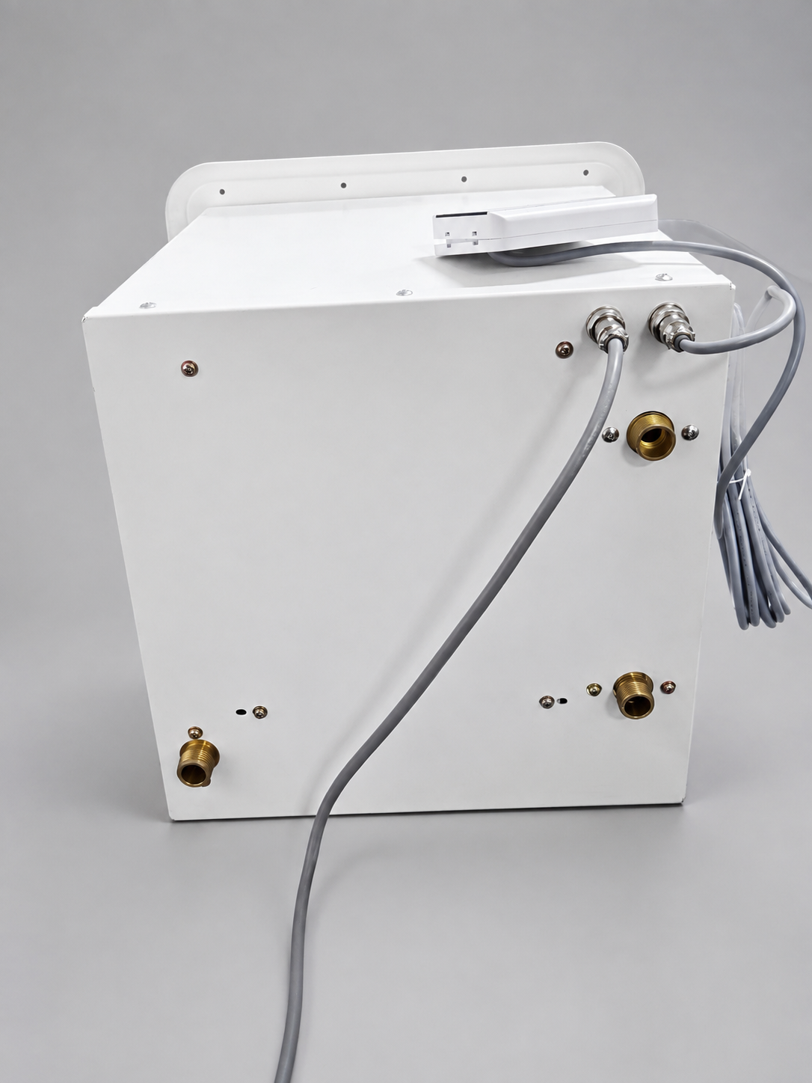
Connection-side arrangement - confirm final production labels and drawing before installation

Water connections
- Cold-water inlet: rear lower-left connection.
- Hot-water outlets: one front and one rear outlet; use the selector valve for the intended outlet.
- Final production configuration uses 1/2 in NPT connections unless the purchase specification states otherwise.
- Flush the water lines before connection. Prevent sealant, metal chips and debris from entering the appliance.
- Install the 150 psi pressure-relief valve and route discharge to a safe location without valves or restrictions.

Gas connection
- Use LPG only unless the appliance rating label explicitly states another gas type.
- Nominal supply pressure is 2.8 kPa. Verify operating pressure under full load with an appropriate manometer.
- Use approved gas pipe, regulator, sealant and manual shutoff components suitable for RV service.
- After connection, test every joint using an approved leak-detection solution. Never use a flame to check for leaks.

12 V DC electrical connection
- Provide a stable 12 V DC supply rated for at least 5 A and protected by a correctly sized fuse or circuit breaker.
- Two-pin power connector: red lead to positive (+), black lead to negative (-).
- Connect the yellow/green protective ground securely to the vehicle grounding point and appliance chassis.
- Route cables away from exhaust heat, sharp edges, moving parts, water and LPG lines.

7. Remote Controller and Operation
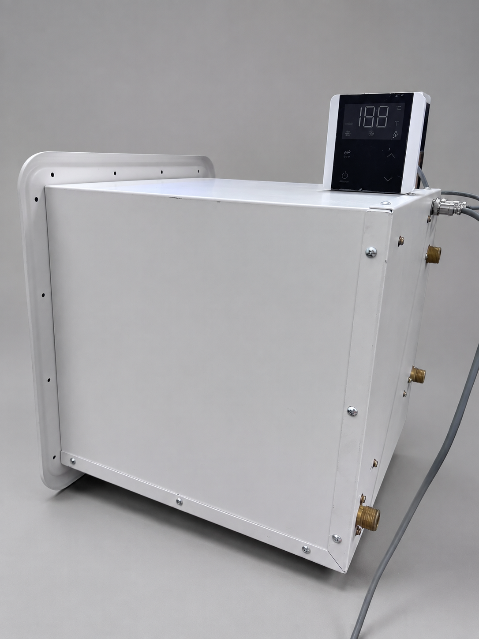
Remote temperature controller - production interface may vary by version

Starting the appliance
- Open the RV water supply and confirm adequate flow.
- Open the LPG cylinder valve and appliance gas shutoff valve.
- Open the exterior access door and switch the appliance main rocker switch ON.
- Switch the remote controller ON.
- Set the desired outlet-water temperature between 35 and 51 degrees C.
- Open a hot-water outlet. The fan pre-purge, ignition and burner sequence will start automatically.
- Verify stable ignition, normal exhaust discharge and stable outlet temperature.

Stopping the appliance
- Close the hot-water outlet. The burner must extinguish and the gas valve must close within one second.
- For extended shutdown, turn the controller and main switch OFF, close the LPG supply and isolate 12 V power.
- Before travel, confirm the exterior access door is closed, flush and locked.
SCALD PROTECTION
Outlet water can cause burns. Always test water temperature before use. Children, elderly persons and persons with reduced sensitivity require supervision.

8. Safety and Protection Functions
Function | Trigger / behavior | Required response
Ignition control | Two ignition attempts, approximately 8 seconds each | If ignition fails, close water and check the displayed fault code.
Flame supervision | Gas valve closes in less than 1 second after flame loss | Do not bypass the flame-sensing circuit.
40-minute timer | Automatic shutdown after 40 minutes of continuous operation | Stop and restore water flow to restart after checking conditions.
Over-temperature thermostat | Approximately 53 degrees C, tolerance +/-4 degrees C | Allow the unit to cool; investigate low flow or blockage.
Freeze-protection thermostat | Approximately 5 degrees C, tolerance +/-4 degrees C | Automatic heating requires normal electrical and gas supply; still winterize when freezing is expected.
Pressure relief | Relief valve rated at 150 psi | Never cap or isolate the discharge path.
Fan monitoring | Fault if required speed feedback is not detected | Check exhaust obstruction, supply voltage and fan condition.

9. Commissioning Checklist
- ☐ Appliance model and LPG rating match the installation.
- ☐ Wall opening, mounting and exterior weather seal match the approved drawing.
- ☐ Exterior door opens, closes and locks correctly.
- ☐ Air intake, exhaust outlet and drain openings are unobstructed.
- ☐ Cold-water inlet, selected hot-water outlet and relief-valve discharge are correctly connected.
- ☐ Water system has been flushed, filled and checked for leaks.
- ☐ LPG pressure is correct under operation and all joints pass leak testing.
- ☐ 12 V polarity, fuse protection, chassis ground and controller connection are correct.
- ☐ Carbon monoxide and LPG detectors are installed and operational.
- ☐ Ignition, flame stability, temperature control, shutdown and fault display have been tested.
- ☐ Owner has received operating, shutdown, travel and winterization instructions.

10. Winterization and Freeze Protection
NOTICE
Automatic freeze protection is supplementary only. It depends on uninterrupted 12 V power, LPG supply and a functional appliance. Drain and winterize the water system whenever freezing conditions are expected or the RV is stored.

Draining procedure
- Turn the appliance OFF and allow it to cool.
- Close the LPG supply and disconnect or isolate 12 V power.
- Shut off the water supply and open a hot-water faucet to release pressure.
- Open the appliance drain points and the RV low-point drains.
- Allow all water to drain. Do not energize or ignite the appliance while empty.
- If RV antifreeze is used, follow the RV manufacturer and antifreeze supplier instructions. Do not use automotive antifreeze.
- Before returning to service, flush thoroughly with potable water and complete the commissioning checks.

11. Cleaning and Maintenance
Interval | Task
Before each trip | Check the access door, lock, intake, exhaust, drain openings, visible wiring and connections.
Monthly during use | Inspect for water or gas leakage, abnormal noise, corrosion, soot or heat damage.
At least annually | Qualified technician to inspect combustion, burner, heat exchanger, fan, gas pressure, safety devices and electrical connections.
As water quality requires | Descale the water path using a manufacturer-approved procedure and potable-water-compatible solution.
Before freezing/storage | Drain and winterize the complete water circuit.

SERVICE RESTRICTION
Do not service gas valves, burner, ignition, fan, control board or safety devices unless qualified and authorized. Use only approved replacement parts.

12. Fault Codes and Troubleshooting
If a fault appears, close the hot-water outlet and follow the safe checks below. If the fault remains, turn off water, LPG and electrical supplies and contact qualified service personnel.
Code | Meaning | Safe check / action
E0 | Outlet-temperature sensor open or short circuit | Check sensor and water-flow-sensor connectors; replace defective sensor.
E1 | Ignition failure or unexpected flame loss | Confirm LPG valve, correct fuel and pressure, ground connection, valve polarity and flame-sensor connection.
E2 | Flame detected when burner should be off | Shut off LPG immediately. Gas valve may be stuck; qualified service required.
E3 | Thermostat fault | Check thermostat wiring. Replace thermostat if defective.
E4 | Inlet-temperature sensor open or short circuit | Check sensor position, connector, specification and inlet/outlet sensor routing.
E5 | Fan speed not detected or below required speed | Check 12 V supply, fan wiring, fan obstruction and fan condition.
E6 | Abnormal high outlet-water temperature | Increase water flow; check for restriction or blockage; allow unit to cool.
E7 | Solenoid/proportional gas valve circuit fault | Shut off LPG. Inspect wiring and valve/PCB through qualified service.
E8 | Fan blocked | Clear exhaust obstruction with appliance off; service or replace fan if defective.
En | 40-minute operating timer completed | Close and reopen water flow to restart after checking conditions.
EC / Ec | Controller communication fault | Check 12 V supply and the 5-pin controller connection.

DANGER
If gas odor, flame outside the combustion chamber, soot, overheating, melted wiring, repeated ignition failure or unexplained shutdown occurs, stop using the appliance and isolate all supplies until inspected by a qualified technician.

13. Transport, Storage and Service

Before driving
- Turn the appliance OFF and close the LPG supply as required by the RV manufacturer and local law.
- Confirm the exterior access door is fully closed, flush and locked.
- Secure loose accessories and verify that no objects obstruct the exterior vent.

Storage
- Drain and winterize the water circuit when freezing is possible.
- Store the RV with LPG and electrical systems isolated according to manufacturer instructions.
- Keep the exterior door dry, closed and protected from impact.

Technical support
Contact Information
Brand | Joelwave
Company | Shanghai LawDawn Consultant Co., Ltd.
Contact | Minato Yang
WhatsApp / WeChat | +86 136 2543 8242
Email | minato@cmg-pmcs.com
Website | www.joel-wave.com
Location | Guangzhou, China

When requesting service, provide the model, serial number, purchase information, destination market, fault code, operating conditions, and clear photos or video of the installation and fault.
DOCUMENT STATUS
This English manual is based on product specification RVW-LP09-01 and the supplied reference manual structure. Final production release must be reviewed against the approved engineering drawing, rating label, certification scope and destination-market requirements.

